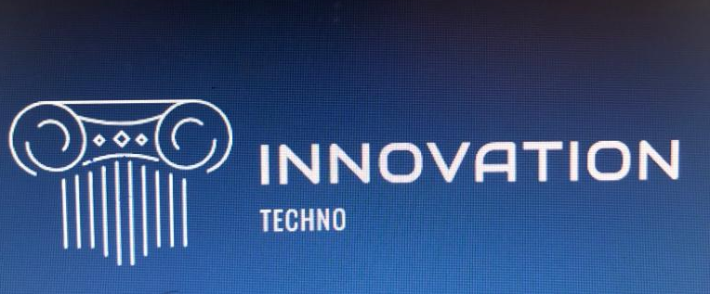
Innovation of Tesla Car Model S
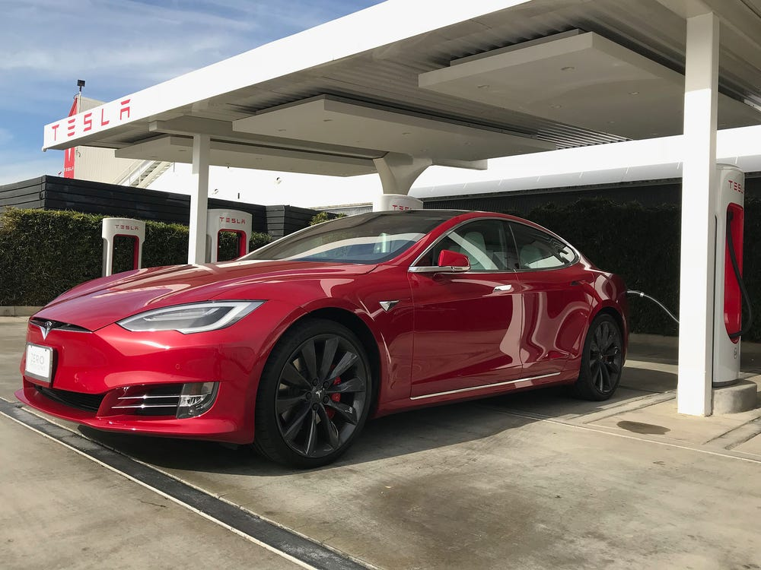

- First model introduced by Tesla was Model S in 2012. It has earned a lot of awards like “Ultimate car of the year”
- Tesla car is seven years old, has not been fully redesigned since then, but 2019 Model S has evolved prominently from the first design.
- The new design has no front grilles and it has sunroofs to increase its range.
Here are all the major changes that has been made in Tesla flagship Model S.
The Tesla car Model S has been recognized and labeled the bestselling car in Norway in 2013 and has been awarded “ultimate car of the year”.

The CEO of Tesla Elon Musk announced on twitter in July that Tesla Model S would not be modified this year, and alike the SUV of Tesla Model X it will only receive minimal changes instead.
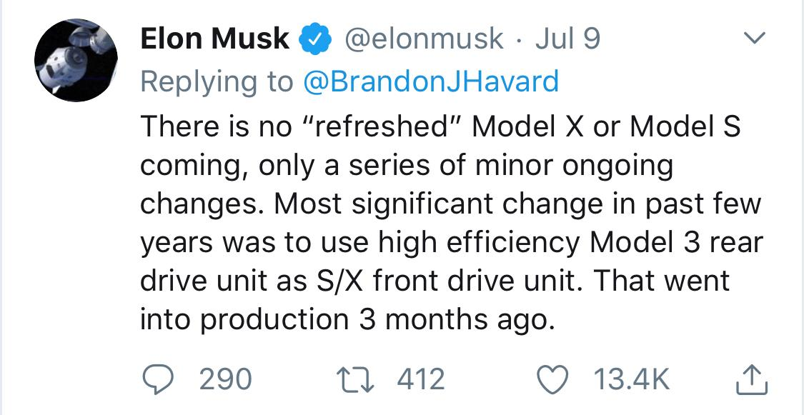

The Model S has undergone many changes, with updates to its drive unit, as well as interior and exterior modifications.
Here are some major changes the electrical Luxury sedan has been made since its introduction, both in programming and driving features.
According to the reports by Green Car the LED daytime running lights were available in 2013 as technology package of the 3,500 dollars. According to the Tesla Motors Club the DRLs became standard equipment after September 2013, even without the package on Model S. the features included in the tech package, keyless entry, seven years of maps, and memory seats.
Tesla 2013 Model S
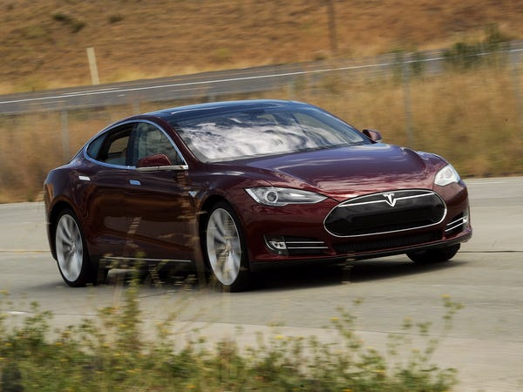
In 2014, tesla’s autopilot driver-assist technology was introduced.
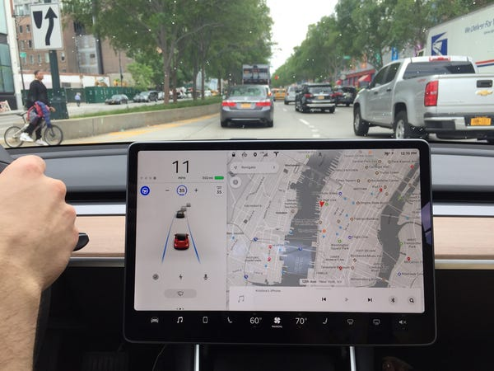
In September 2014 autopilot became an add-on option in Tesla. At the end of the year in all new Model S cars, the camera, radar, and ultrasonic sensor hardware were introduced as necessary addition. These functions could be activated at any time for an additional charge.
On October 2014 first dual electric motor P85D production car in Tesla Model S was released by the company. For a longer and better battery range and performance electric motor on each axel were added.

In 2015, the premium interior package created by Tesla.
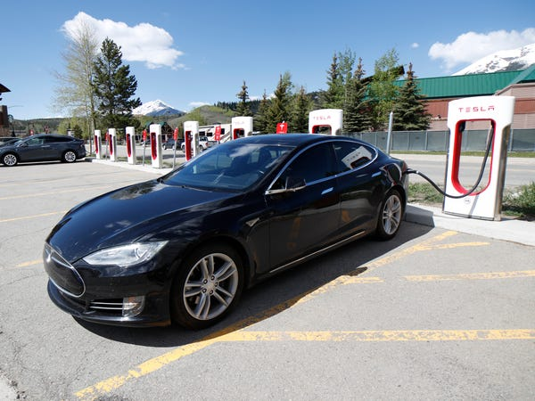
The premium interior package included the executive rear seats option, according to Car and Driver. The ERS provided two rear seats with two zone heaters and controls that are required to adjust media, climate, and panoramic roof settings with the app of Tesla, by passengers.

In 2015, the new Ludicrous mode for the P90D was announced by Tesla.
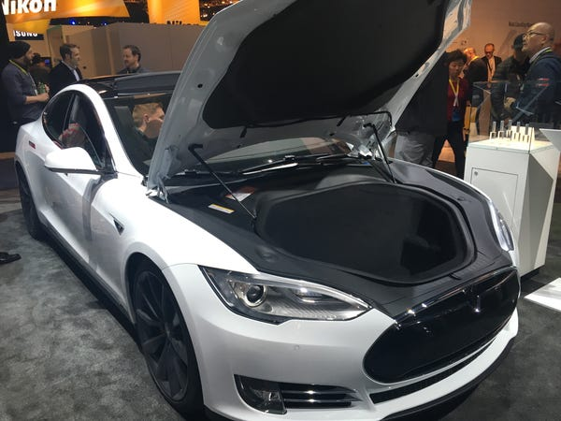
According to Motor Trends, this new Ludicrous Mode brought the time from 3.1 to 2.8 seconds. The price tag to avail this option was 10,000 dollars, and was only available for the latest top of the line P90D.
According to the Green Car Reports, the model S70D contained a new battery of 70kWh which replaced 60kWh version.

In 2016, The solid glass roof became an option.
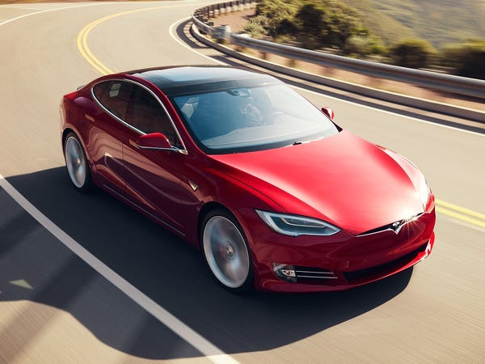
Minimal changes to the Model S were made in 2016 model year. Most of the faux-front grille in 2016 model were removed by Tesla, giving it a cleaner look from the front. According to the Electrek, a new vegan interior option was added to the Model S P100D.

In 2017, Tesla bumped up the performance.
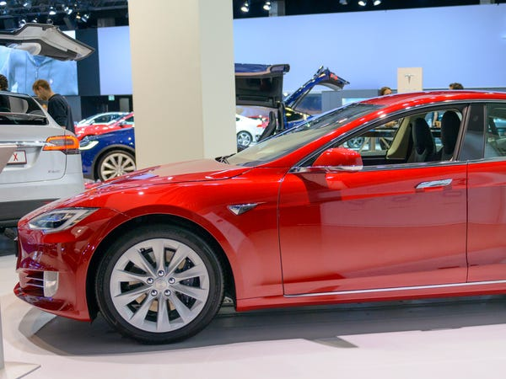
According to Electrek, Quoted Model S was improved by Tesla by giving zero-to-60 mph performance times. Time dropped from 5.5 to 4.3 seconds in the Model S 75’s. And the latest Model S 100D quickened to 4.1 seconds.

The roof options were changed by Tesla in 2018, with the panoramic sunroof removed as option.
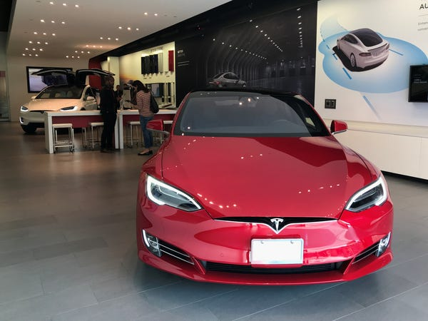
Several options were cancelled by Tesla in 2018. According to Elecrek, the panoramic sunroof was removed by the company in 2018. The black textile interior, rear-facing child seats, and 21 black Arachnid wheels options was also removed by Tesla. These changes were done because they wanted to simplify the product offerings for customers, said by Tesla.

In 2019, Tesla increased the battery range in Model S, Long range increased by 105 miles.
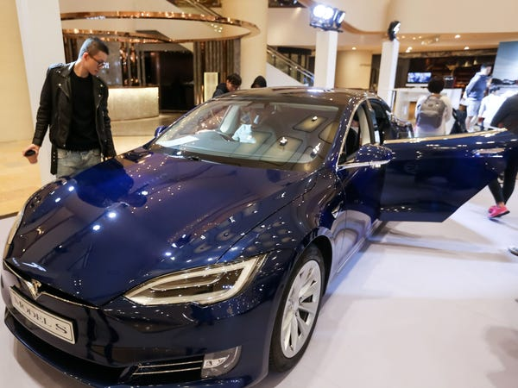
When the first model of Tesla car that is Model S was released, it had a range of 265 miles. According to Motor Trends, Now the latest and updated model has Long range option and has 370 miles range with the help of latest electric motor. Low rolling resistance tires are also added by Tesla.
In early year 2019, to outfit the car, Tesla dropped the option with a smaller and a smarter battery, removing the 75 kWh. Elon Musk tweeted. This left the base level battery at 100kWh. 2019 Tesla is with Upgraded air suspension.

